Problem 1 (30 pts): Two reactants A and B react in the cell cytoplasm to produce two products X and Y. Y is utilized in a subsequent reaction as fast as it is produced, so that its concentration remains virtually zero. That makes the reaction irreversible. The irreversible chemical reaction equation is
$A+B \underset{→}{k} X+Y$
Let a, b, x, and y denote the respective concentrations of each substance. Assume that the initial concentrations are: a₀ = 10.5 $μg/ml$, b₀ = 6.5 $μg/ml$, x₀ = 0, y₀ = 0. The rate of reaction constant is k = 2.0/s.
You have to take into consideration conservation of mass.

- Assess each of the statements below, say whether the statement is true or false and substantiate with logical explanation.
  - The model of the reaction kinetics is $\frac{dx}{dt}=2\left(10.5-x\right)\left(6.5-x\right):$ (True/False)
  - The model of the reaction kinetics is $\frac{dx}{dt}=2\left(10.5-x\right)\left(6.5-y\right):$ (True/False)
  - Reactant A gets depleted first. (True/False)
- Next, create a Simulink simulation of the correct model.
- Finally solve the differential equation of the correct model using Matlab symbolic language

Problem 2 (40 pts)
(see diagrams below)
Consider the following irreversible intracellular reaction in which one mole of X reacts with one mole of Y to create one mole of Z with forward rate constant of k₁. Denote the concentrations of X, Y and Z as x, y and z (respectively). Both X and Y diffuse into the cell from the extra-cellular fluid (ECF) with diffusion coefficients of k_{x} = 2 $\frac{μg}{sec}$and k_{y} = 3 $\frac{μg}{sec}$ (respectively). Extracellular X and Y are carried by albumin and there is a large reservoir of each in the carrier state. We are only interested in the free X and Y. Because there is a large reservoir, we can assume that the concentrations of free X and Y in the extracellular fluid are constant and equal x_{0e} = 10$μg/mg$ and y_{0e} = 6 $μg/mg$. Assume that the initial conditions for all intra-cellular fluid (ICF) reactants and product are zero: x_{0 i}= y_{0i} = z_{0i} = 0.
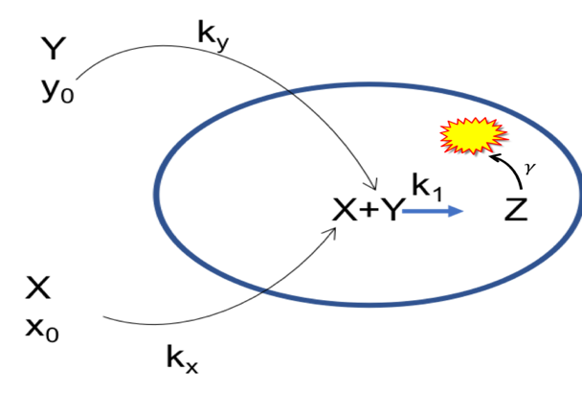Also we know that the product of this reaction, Z, is consumed by a subsequent reaction in the cell proportionate to its concentration with a proportionality constant of $γ=2/sec$
Furthermore, there is a negative feedback mechanism where z, the concentration of Z, inhibits the forward progress of the reaction, X+Y Z, in the following way: $k_{1}=α-βz$ and k₁ is always $≥0$ (see graph)
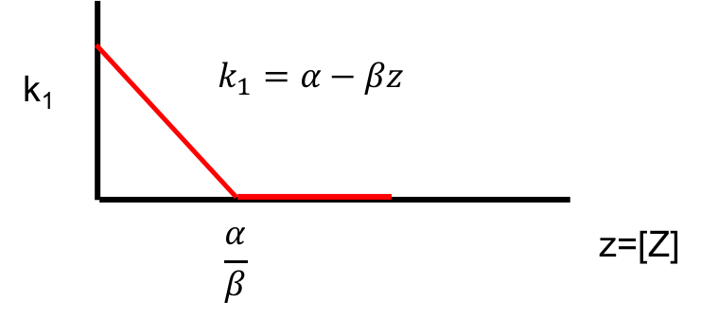
Let $α=10 \& β=2. Clearly, as z→\frac{α}{β} , k_{1}→0 and the reaction will stop if k_{1}=0$
Write the dynamical system that describes this situation (differential equations)
- Create the Simulink model for a numerical solution. Run the model for 5 seconds. Present your output (don’t forget labels, title, etc.). The presence of Z inhibits its own production, but Z is also consumed thus reducing its presence
- Identify equilibrium point(s). What are they (numerical values)?
- What happens to k₁? Does it go to zero? If not, what is its final value
- Does the operation stop or just reach a steady state?

Problem 3 (30 pts)

A nerve cell has the following ionic concentrations inside and outside the cell:

Inside | Outside
Na⁺ 14 mMol | 140 mMol
K⁺ 140 mMol | 4 mMol

The measured membrane potential = -79.3 mV.
Note that R = 8.3 J/K,
temperature = 37⁰C,
F = 96500 C/mole
Z=1 for both ions
$2.303\frac{RT}{ZF}=61.5$ using log base ten
Assume that Na+ and K+ are the only permeable ions.
The ratio of gNa:gtotal = 0.1,
the ratio of gK:gtotal = 0.9

ion conductance for each ion is a constant and does not change with changing ion concentrations.
- Calculate what happens to the membrane potential if extracellular K⁺ is increased by 25 mM. Show your work.
(Note this problem can be solved with pencil, paper, & calculator, with Matlab command window – be sure to use the correct log function - , or on Excel equally easily)
- Research the concept of membrane voltage threshold and action potentials.
  - Write a short essay explaining what this entails.
  - The extracellular potassium ion level can be suddenly increased by 25 mMol/L, say by intravenous injection of KCl. Why do you think that this will be a lethal injection?

